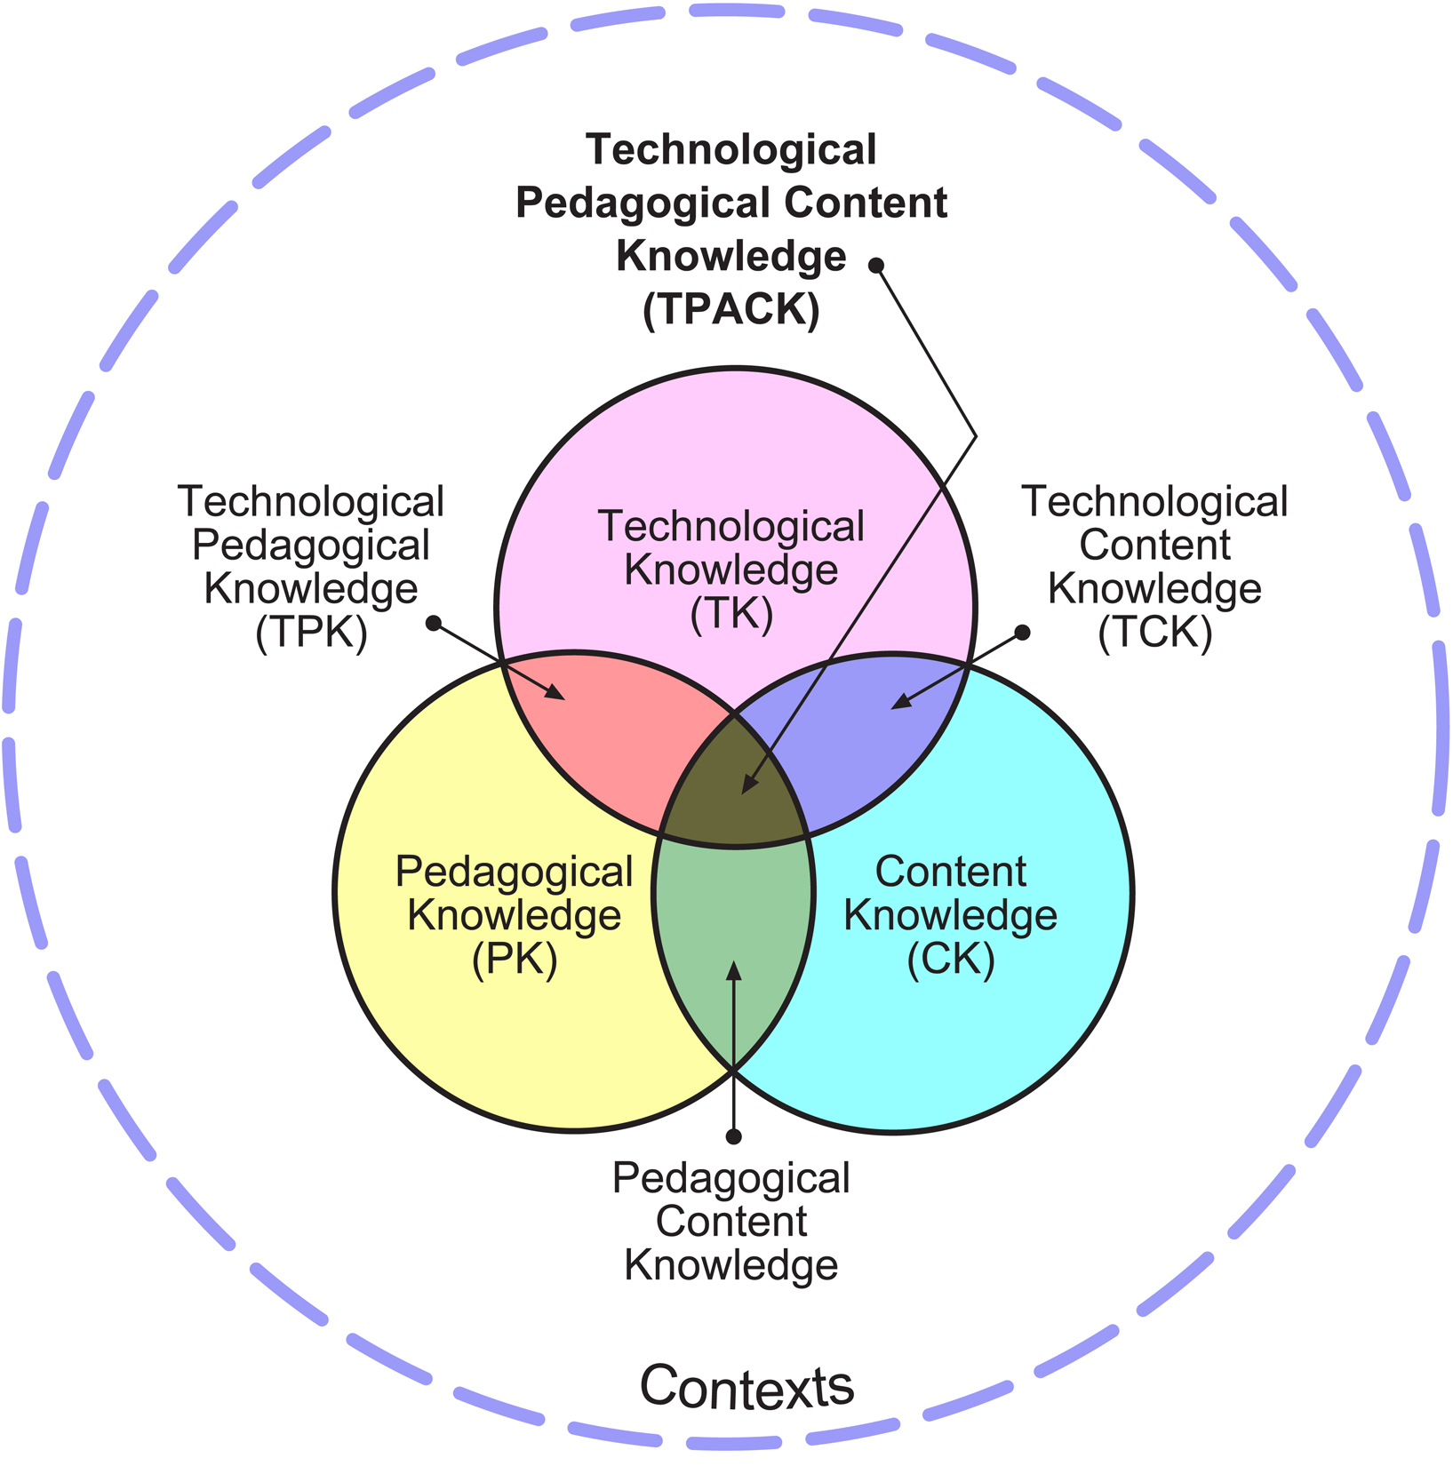
‘Pedagogy First’ Learning Design Guide

1. Lesson Aims

Goals/Objectives/Outcomes
What it is students need to learn? Define as precisely as possible.

2. Lesson Foundations

Overarching pedagogy/pedagogies
What overarching pedagogical approach/approaches may be suitable?

Content
What sort of content is being addressed and what sort of thinking skills are being developed?

Context
What context can be provided to promote student motivation and engagement?

3. Lesson Activities

Brainstorm Possible Lesson Activities
What are some initial ideas about the sorts of activities that could be used to help students to develop the required knowledge, skills and attitudes? | (leave blank initially)
How might the activities above be sequenced to promote effective learning? Order them.

4. Technologies

Brainstorming possible technologies
What technologies, based on their affordances, do I have at my disposal to facilitate and support pedagogies, interactions, and content representation?

Now map these into the second column of the Lesson Activities Table

Having thought about the pedagogical and learning objectives, do the available technologies inspire any new ideas for types of tasks? If so, make amendments in the Lesson Activities Table.

5. Assessment

Appropriate assessment tasks
How will students be assessed as having met or progressed towards the learning outcomes?

6. Fine tuning
- How can the presentation and sequencing of the tasks be optimized to promote student learning? (for instance, efficiency of words for task instructions, using the most effective form of representation to share knowledge and skills, using modalities together in cognitively efficient ways, using increments appropriate for the ability level)
- How have learning supports (scaffolding) been provided within tasks and overall to assist learning? (links to further information, feedback, hints, suggestions, prompts, clear instructions about groupwork processes etc)
- Does the lesson operate at the desired levels of thinking (for instance Lower Order Thinking as opposed to Higher Order Thinking)?
- Is the length of the lesson too long or short (place yourself in the mind of the learner)?
- Check: Is there alignment between my learning objectives, tasks, and assessment (“Constructive Alignment”, Biggs & Tang, 2011).

‘Pedagogy First’ Learning Design Guide (Notes)
This guide has been created to support teachers in the design of technology-enabled lessons. It is not a prescription, but rather a logical sequence of critical elements and questions to help structure the learning design process. It is based around the Technology Pedagogy And Content Knowledge model of teacher practice, but asserts that Pedagogy and Content thinking should precede the consideration of Technology.

1. Goals/Objectives/Outcomes
These are often defined by a syllabus or curriculum.

2. Lesson Foundations

Overarching pedagogy/pedagogies
Some possible pedagogical approaches include:

- Behaviourist – suitable for recall of facts, such as spelling, multiplication tables, language memorisation
- Constructivist – suitable for logical domains, deductive reasoning, systems thinking, for instance in STEM subjects (Science Technology Engineering and Mathematics)
- Socio-constructivist – suitable where knowledge is to be negotiated, is subjective, or where peer exchange, debate and guidance will enhance understanding of material and development of skills
- Constructionist – where students will learn by making, not just through simulation or a series of learning experiences that build upon one another
- Connectivist – suitable for complex and rapidly changing domains, where learning from and with people helps to remain up to date or quickly form new understanding

Note that proposed applications above are only suggestions – each pedagogy can be applied outside the context suggested and often other pedagogies can be applied within that context. As well, more than one pedagogy may be applied during a lesson. At this stage it may also be possible to draw upon pedagogical patterns, such as “Think-Pair-Share” or “Predict-Observe-Explain” to structure the lesson.

Content
Aspects to consider are:
- The nature of the knowledge type/s being represented (factual, conceptual, procedural, metacognitive)
- The nature of the cognitive processes being developed (from lower order recall, understand, apply, to higher order analyse, evaluate, create)
- What sort of modalities are appropriate for representational purposes (for instance, factual knowledge: text, image; procedural knowledge: video, sometimes audio; conceptual knowledge: images, diagrams)

Context
Possible motivating contexts include:
- Authentic contexts and tasks
- Role plays
- Gamification

3. Brainstorm Possible Lesson Activities
Possible lesson activities include:
- Activating prerequisite knowledge so that students recall the required facts, concepts and skills
- Providing instructional information and resources
- Interactive tasks (students share their ideas with peers, with teacher)
- Investigative tasks
- Practice tasks
- Debates
- Creative tasks
- Groupwork tasks
- Formative assessment to check student progress
- Summative assessment to evaluate overall learning
Also consider:
- Does the lesson cater to student diversity (differentiate the curriculum)?

4. Technologies
Possibilities include:
- Wikis
- Discussion boards
- Multiple choice questions
- Written responses e.g. in a text area
- File sharing
- Videos
- Mindmapping
- An almost infinite range of Web 2.0 technologies and apps

When mapping to the learning activities, consider the affordances of the technologies, and how they relate to the affordance requirements of the activities in terms of concept representation and interaction. Consider:
- What sort of information can the technology represent (For instance, factual knowledge: text, image; procedural knowledge: video, sometimes audio; conceptual knowledge: images, diagrams)
- What sort of discourse and collaboration do they enable (for instance, one directional broadcast, discussion, individual construction, co-construction)

It is important to revisit the possible activities in light of the available technologies – sometimes technologies inspire creative activity ideas. However, the approach adopted in this Learning Design guide is that consideration of the pedagogical elements needs to have proceeded the technological elements so that fundamental learning requirements are met.

5. Assessment
Points to consider include:
- The level required (conditions, behavior, performance)
- Authentic assessment – completing tasks that students will find relevant and realistic

6. Fine tuning
It is important to continually reflect upon and fine tune a learning design. Designing lessons is as much art as science, and in this respect it cannot be purely linear. Seek feedback from a several people in order to support the refinement process.

Relevant topics for further reading
- Understanding by design
- Learning by design
- Designing for learning
- Design thinking
- Learning design
- Educational design research

