EXAM SUPPORT STAFF BRIEFING

This document contains info on:
- Booking a computer on campus
- Responding to student issues
- Responding to students registered with Accessibility

Online collateral for the Exam Hotline:
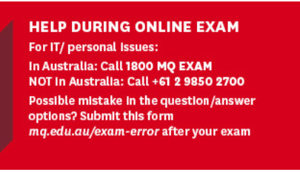
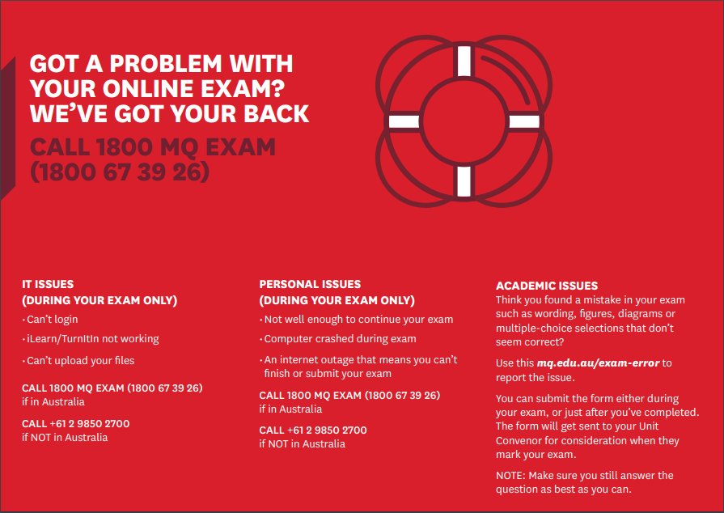

Request for access a computer to complete their Exam
Students that require either a computer or access to the internet, due to no, limited or inconsistent access at home are able to book a space on campus. Rooms 218 and 219, 17 Wally’s Walk have been made available (total of 99 computers are available, overflow will be arranged if required).
Students must submit a “Request for computer access” form (see link below) prior to their exam. Allocation and communications will be managed by the Exams team, and whilst all will be done to accommodate students who just turn up, access cannot be guaranteed unless the form is completed.
Additional cleaning has been arranged and hand sanitisers and wipes will be made available.
Students must have a campus card to enter, no other form of ID will be acceptable.
https://mqedu.qualtrics.com/jfe/form/SV_71YIKz8ph4v8WgJ

Responses to student issues during Exams
If you are not on the 1800 MQ EXAM phone line, to save the student being transferred unnecessarily to 1800 MQ EXAM, if a student calls with any of the following issues during exams please respond/action as per the below.
Please complete the following interaction form if you speak with a student
https://forms.office.com/Pages/ResponsePage.aspx?id=wRTFghenh0C-BtQNIHCtUrvHtAqSCapOoLqJAdZyuy9UQ1JFRjZNMkVRTENENjRQS1JZSElDNUI4Si4u

If the student is having an issue other than the below, please transfer to 1800 MQ EXAM

Personal Issues During the Exam:
Missed their sitting:
“If there were extenuating reasons for missing your assessment window, please submit a Special Consideration form. I will make a note on your profile that you rang which can be referenced as evidence”
Make a note in tracker against the student’s profile. Include exam/unit name and any relevant info (no detail required). There may be students that simply forgot – therefore unless the unit has additional offerings there is no alternative to arrange another exam (without a special consideration being submitted), and the student may not pass the unit (SC* grade, not an F grade will be recorded against the unit)
SC = Special Circumstance

They/dependent/carer are sick:
“If you are unable to complete your assessment, please submit a Special Consideration form. I will make a note on your profile that you rang which can be referenced as evidence”
Make a note in tracker against the student’s profile. Include exam/unit name and any relevant info (no detail required)
Internet/Computer issues:
Has the student Commenced their exam sitting?
If Yes:
“If you are unable to complete your assessment, please submit a Special Consideration form. I will make a note on your profile that you rang which can be referenced as evidence”
The internet or computer issues may or may not have had significant impact on the student’s exam, the student needs to make their own determination whether to continue. However, if the student is going to submit a Special Consideration, they should not continue their exam. Make a note in tracker against the student’s profile. Include exam/unit name and any relevant info (no detail required)
If No:
“If you have not yet commenced your exam, are you able to travel to campus in a reasonable time?” If yes, direct the student to the Request for Access form and explain there is space available on campus for students to sit their exams.
If the student is unable to travel to campus within their exam window, suggest they submit a Special Consideration form.
IT Issues During the Exam:
Unable to log in to iLearn:
“If you are unable to access iLearn I will put you through to IT Helpdesk who can assist you”
(dial 1600) Priority extension – for staff use only for students sitting an exam at that moment
Unable to submit assessment/unable to upload document:
“If you are unable to access iLearn I will put you through to IT Helpdesk who can assist you”
(dial 1600) Priority extension – for staff use only for students sitting an exam at that moment

Academic Issues:
Academic issues regarding questions will be dealt with after the exam and will not be looked at or resolved during the exam, as we cannot guarantee that all students would be able to provided (and see) any corrections or clarifications in a timely manner. If a correction or amendment is required it will be taken into consideration when the exam paper is marked.
Error in multiple choice answer:
“If you believe there is an error in your exam, please complete the question to the best of your ability, take note of the exam question and the possible error, then submit the exam error form once you have finished. If it is deemed to be a genuine error, it will be taken into consideration at the time of marking. No one will be disadvantaged. The form can be found at “mq.edu.au/exam-error”
Grammatical error altering meaning of question:
“If you believe there is an error in your exam, please complete the question to the best of your ability, take note of the exam question and the possible error, then submit the exam error form once you have finished. If it is deemed to be a genuine error, it will be taken into consideration at the time of marking. No one will be disadvantaged. The form can be found at “mq.edu.au/exam-error”

iLearn Screenshots:

The intention is to have the Exam Hotline advertised in two places in iLearn for the online quizzes. If convenors choose to use Turnitin rather than quizzes, the information will be displayed differently.

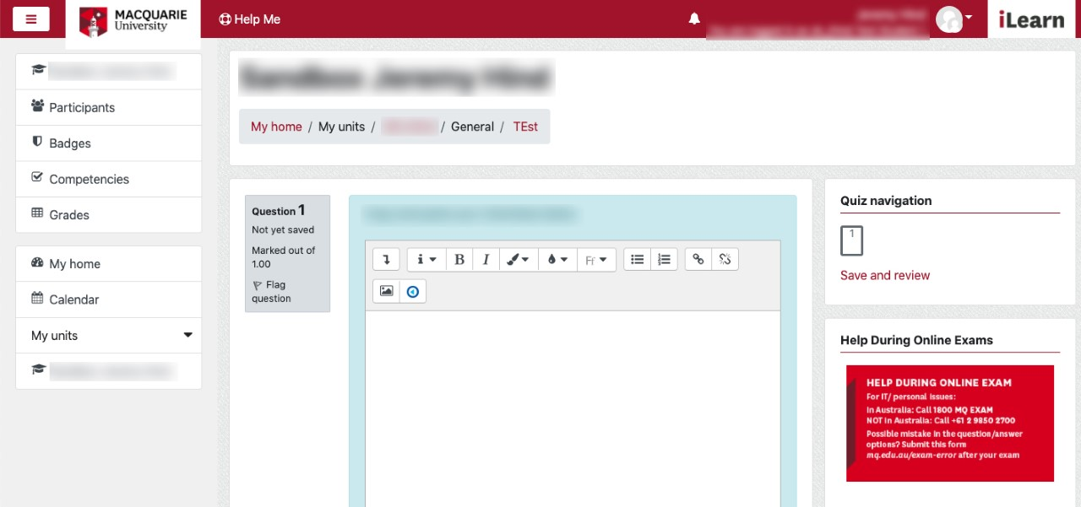

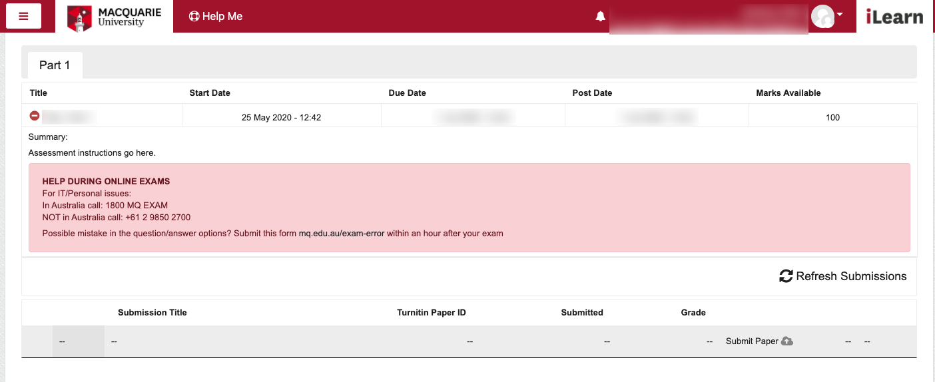

Exam Error Form Screenshot:
mq.edu.au/exam-error All fields are mandatory

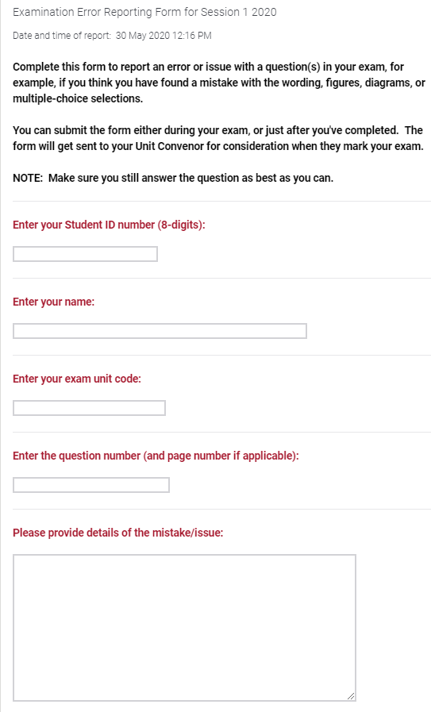

Accessibility related support

Below is a list of common questions that may come through relating to exam adjustments.
If any of the below enquiries come through the 1800 MQ EXAM line within Business hours then the call can be transferred to the Wellbeing phone (ph: 9850 7497). The admin team will then refer the student to the right person managing the specific exam or the allocated Disability Advisor.
For out of hours enquiries the student can contact the 1800 CARE MQ (1800 22 73 67) line who will follow the same process to reach out to the relevant staff member to assist.
Common question:
- I don't think my extra exam time has been added
- I think I am meant to be given extra exam time, but i'm not sure if it applies for my exam today?
- can someone tell me what extra time I will get for my exam today
- There are questions in my exam that I can't read due to my disability- what do I do? (i.e pictures/graphs etc)
- I'm late starting the exam at the time I had scheduled with the disability adjustments team- what do I do now?
- My exam cut out even though I am meant to have extra time added. What do I do?
- My extra time was added but I think it was the wrong amount?
- I have a disability and can't access my exam (due to assistive technology not working etc)
- I have to sit an exam at a different time than I had arranged, and my extra time needs to be added/can it be added?

Individualised emails with confirmed adjustment arrangements sent 2 June to all students. The email will list exam start time/finish time and extra time arrangements, plus contact details of Exam hotline, Wellbeing and Out of hours support etc.

